Chapter 6, Solution 16

The equivalent capacitance at terminals a-b in the circuit in Fig. 6.50 is 30 μF. Calculate the value of C.

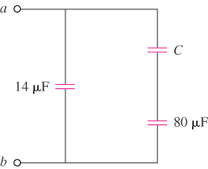

Figure 6.50
For Prob. 6.16.

Solution

$$C_{eq}=14+\frac{Cx80}{C+80}=30\begin{matrix} & \underset{→}{ }\end{matrix}\begin{matrix} & \underline{C=20 μF}\end{matrix}$$

